PARENT DISPUTES POLICY
BOROONDARA PARK PRIMARY SCHOOL
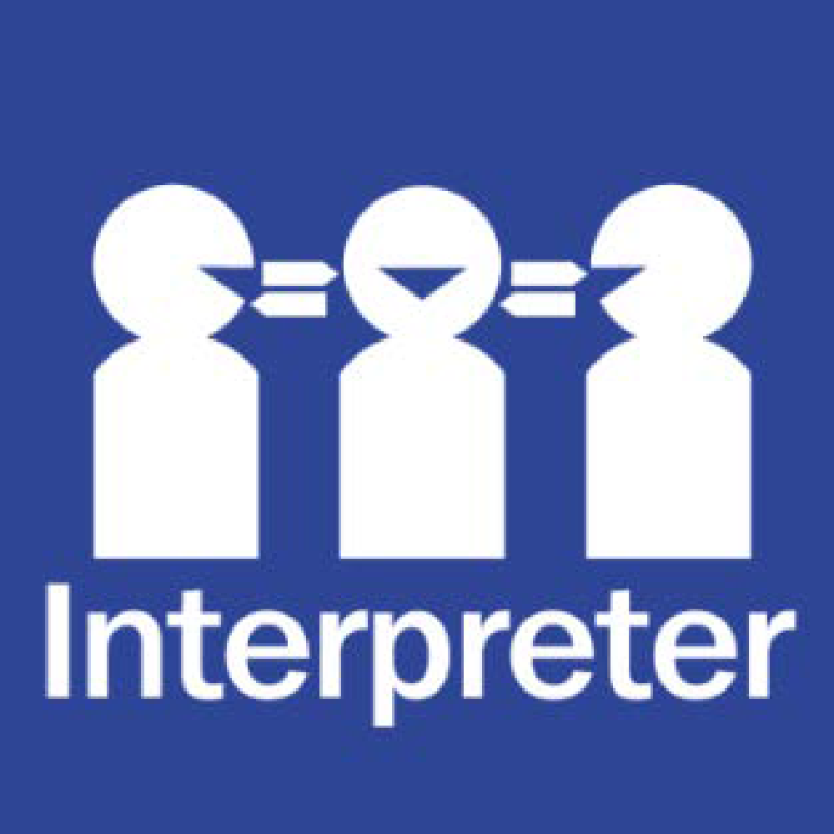
Help for non-English speakers
If you need help to understand the information in this policy please contact the main office on 9857 5157 or email at Boroondara.park.ps@education.vic.gov.au

PURPOSE
The purpose of this policy is to explain to the Boroondara Park Primary School community how our school will approach disputes that may arise between parents in relation to decisions about a student’s education.

SCOPE
Boroondara Park Primary School acknowledges and welcomes all family structures and parenting arrangements, including single parents, step-parents, same-sex parents, co-parents and informal carers. We also recognise that parents and carers play an invaluable role in a child’s learning and wellbeing by being actively involved in school life.
While acknowledging that a range of people may be involved in providing care for students at our school, this policy only relates to disputes between a student’s parents or persons with parental responsibility under a court order.

Informal carers
Boroondara Park Primary School understands that there may be families in our school community where students are being cared for by a grandparent, other relative or other adult, rather than their parents.
In these circumstances, in order to allow these carers to work with Boroondara Park Primary School and make decisions about the student’s education, we may ask carers to complete an Informal Carer Statutory Declaration Form. This is a written statement that sets out the care arrangements for the child.
Generally, an informal carer who has provided the school with a completed Informal Carer Statutory Declaration may make school-based decisions for the student and may access school information ordinarily provided to a parent.

POLICY

Decision-making and parental responsibility
Parental responsibility is defined as all of the duties, powers, responsibilities and authority, which, by law, parents have in relation to their children. Each parent of a child under 18 years of age has parental responsibility for his or her child unless this responsibility is varied by a court order or parenting plan.
When a decision relates to a major long-term issue for a student, Boroondara Park Primary School will generally seek to approach both parents, or those who have parental responsibility, in relation to that decision (where those parents are known to and are in contact with the school).
For day-to-day decisions, Boroondara Park Primary School will generally approach the person with whom the student is living with or residing with on that day.
Parents can find more guidance on how the school will manage decision making for students in the Department’s policy on ‘Decision Making Responsibilities for Students’. https://www2.education.vic.gov.au/pal/decision-making-responsibilities-students/policy

Family Law Act Orders and Care Arrangements
Parents are responsible for providing Boroondara Park Primary School with up-to-date information and documentation relating to:
- Family Law Act Orders
- parenting plans
- informal arrangements that are in place with respect to students at our school
It is not the responsibility of school staff to monitor or to enforce Family Law Act Orders (or other parenting or care arrangements) for students.

Intervention Orders
Boroondara Park Primary School understands that some families may have Family Violence Intervention Orders in place.
Parents are responsible for providing Boroondara Park Primary School with up to date information and documentation relating to Intervention Orders and should contact the school’s office to speak with the principal to discuss how staff can best support students in these circumstances. Should your Intervention Order be changed or varied, it is important that you inform our school and provide any updated documentation.
Department policy states that breaches of Intervention Orders should be reported to Victoria Police.

Enrolment and transfer
If parents who have equal shared parental responsibility disagree on the decision to enrol a student, Boroondara Park Primary School may:
- defer admission and request that parents resolve their dispute and reach an agreement, or
- if failure to enrol the child or young person is likely to have an adverse effect on their education and wellbeing, Boroondara Park Primary School may conditionally enrol the student and encourage the parents to resolve their dispute and reach agreement.

Collection
Boroondara Park Primary School understands that Family Law Act Orders or parenting plans will often include arrangements about which parent is to spend time with the children, and when.
Generally, providing that both parents have shared parental responsibility, parents can collect their children from school. Whilst Boroondara Park Primary School encourages parents to abide by Family Law Act Orders, school staff are not responsible for enforcing them.
If a dispute between parents over the collection of a student happens at Boroondara Park Primary School, generally, we will:
- encourage the parents to resolve their dispute away from school
- encourage the parents to ensure the child’s attendance at school is not compromised as a result of the dispute over collection
- where appropriate, move the student to a safe place away from the dispute
- ask the disputing parties to leave the school grounds if the dispute is causing disruption or concern to the child or any other members of the school community
- if the dispute cannot be resolved, Boroondara Park Primary School may contact Victoria Police and/or Child Protection.

Visits during school hours
We understand that there may occasionally be a reason why a parent or carer may want to speak to or see their child at school, during school hours.
If there is a particular pressing or unavoidable issue that cannot wait until the end of the school day, we ask that parents or carers call the school office to make the request to speak to or see their child during school hours.
We also ask that parents avoid arranging to visit their children at school wherever possible, as this can cause inappropriate disruptions to the school day.
All parents or carers who visit our school during school hours, other than during usual school pick up and drop off times, are required to sign in as a visitor at the school office.
School expos and other school events
We will work with parents, where practicable. to allow for allocated slots at events to be made available for both parents of a child at times that are seperated where there are conflicts in the relationships.

Requests for information
All parents are generally entitled to information ordinarily provided to parents, including school reports and newsletters.
Parents seeking information that is not ordinarily provided to parents are encouraged to apply for access through the Freedom of Information process, or, if the information is sought for use in court proceedings, by issuing a subpoena.
Freedom of Information requests should be directed to:
Manager – Freedom of Information Unit
Department of Education and Training
2 Treasury Place
EAST MELBOURNE VIC 3002
03 9637 3134
foi@education.vic.gov.au

Managing disputes
Whenever faced with a dispute between persons who are responsible for decision-making in relation to a child, staff at Boroondara Park Primary School will seek to:
- avoid becoming involved
- avoid attempting to determine the dispute
- act neutrally and not adopt sides
- act in the best interests of the student involved
- act in the best interests of the school community
Boroondara Park Primary School encourages parents and carers to seek the assistance of the Family Relationship Centre or obtain independent legal advice if they are unable to reach an agreement about important decisions.
COMMUNICATION
This policy will be communicated to our school community in the following ways:
- Available publicly on our school’s website
- Included in staff handbook/manual/staff induction
- At student forums
- Transition/enrolment packs
- Discussed at annual staff briefings/meetings
- Discussed at parent information nights/sessions
- Reminders in our school newsletter
- Hard copy available from school administration upon request

FURTHER INFORMATION AND RESOURCES
- the Department’s Policy Advisory Library:
  - Decision Making Responsibilities for Students - https://www2.education.vic.gov.au/pal/decision-making-responsibilities-students/policy
  - Requests for Information About Students - https://www2.education.vic.gov.au/pal/requests-about-students/policy
  - Intervention Orders - https://www2.education.vic.gov.au/pal/intervention-orders/policy
POLICY REVIEW AND APPROVAL

Policy last reviewed | 3 September, 2021
Approved by | School Council
Next scheduled review date | 2022

